HDSRL 2014 race #3 – East Harlsey, Northallerton
Wednesday 4th June, race starts 7.45pm
Organised by Swaledale Road Runners
UKA race license applied for
Single lap course, same as 2012, easy to follow, just under 10km, nearly all good road – short section of rougher, farm road, finish on grass (only 100 metres)
Takes in part of the Coast to Coast route
Meet at East Harlsey Cricket Club, near Northallerton (GR: 423994)
Travel: The Race HQ is at East Harlsey Cricket Club where parking is available - Please DO NOT park in the village or at the Cat & Bagpipes PH.
From Northallerton
Take A684 west to Osmotherley, A19 Teesside
East Harlsey village is signposted to the left after approximately 5 miles
Follow this road for 1.5 miles and the cricket field is on your left before you enter the village, at the bottom of a hill
From A19 South
Leave A19 at the turn for the A684 to Northallerton/Osmotherley. Head towards Northallerton for approximately 1 mile before turning right to East Harlsey.
Follow this road for 1.5 miles and the cricket field is on your left before you enter the village, at the bottom of a hill
Follow marshals directions/instructions
The Start is from the Cat & Bagpipes Public House which is 5 minutes walk from the cricket club. Runners will be led from the cricket club to the Start at 7.35pm.)
Limited male and female changing available at the cricket club.
Toilets available at the cricket club and at the Cat & Bagpipes.
Buffet served afterwards at the Cat & Bagpipes PH.
Like all races in the League this is open to members of HDSRL affiliated clubs only - sorry, no guest runners, no unattached runners.
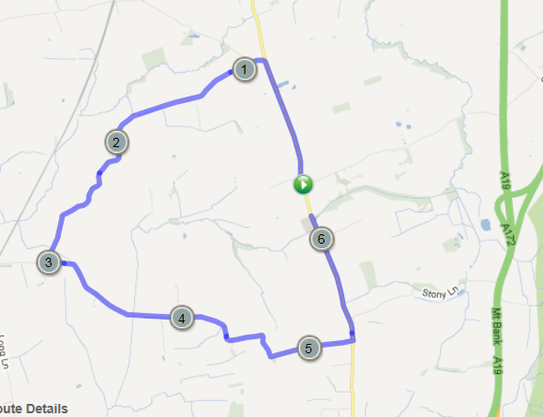
Route Map:

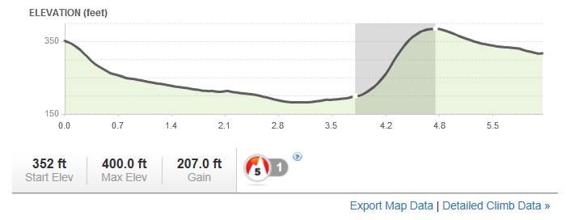
Elevation:

